3 “PERSONAS”

*Survey Taker, Business/Company , Admin*

**Survey Taker -** will only be given the ability to take the survey. They will be sent an email or text by the Business giving them a unique survey code and a link to our web app. Once they click on the link they will click “TAKE SURVEY” , which will then prompt them to enter the code, once the code has been successfully entered they can then take the survey. The following is the view they will have.

**SURVEY TAKER VIEW**

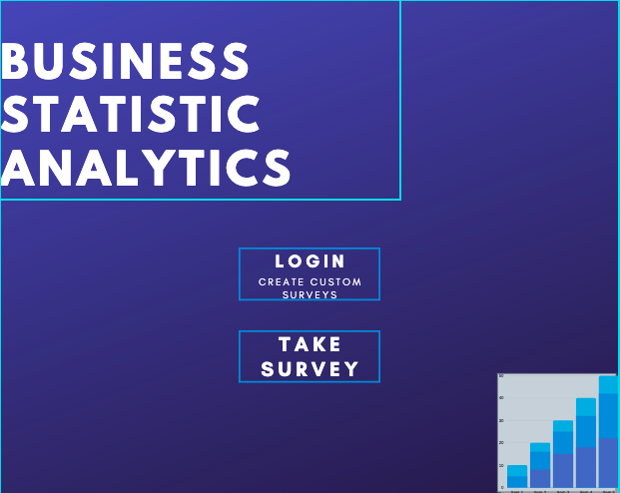

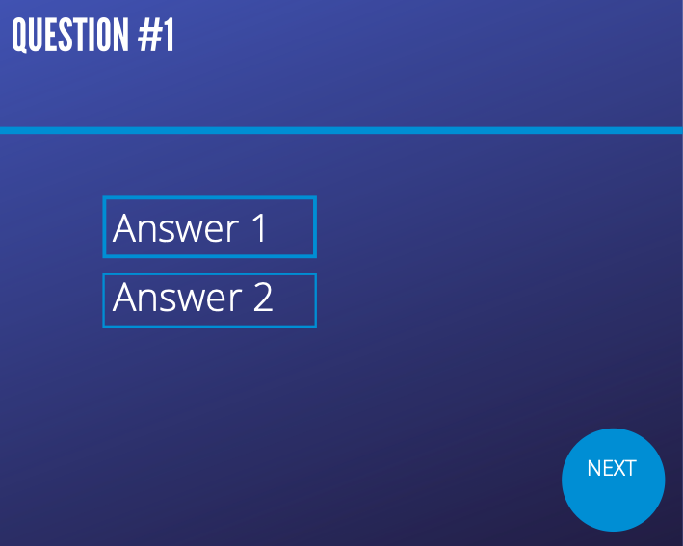

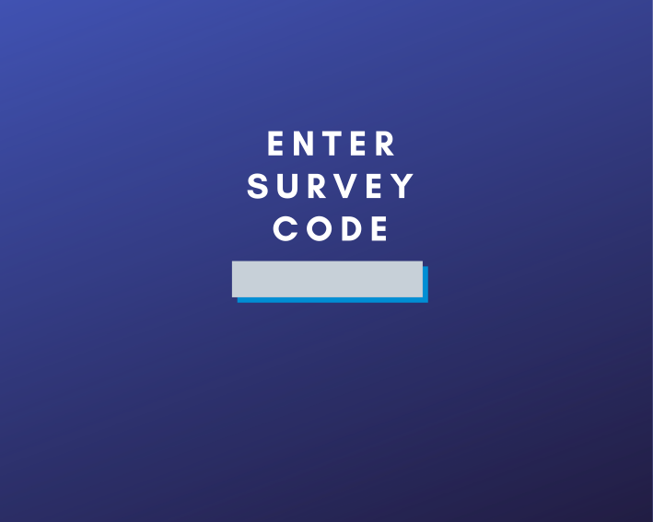



**BUSINESS/COMPANY VIEW (CREATE SURVEY)**

**Business/Company -** are given the ability to create surveys and view results. At the home page Business should click the “LOGIN” option which will prompt them to enter a email and password. After they have successfully logged on to their account they will have the option to view results 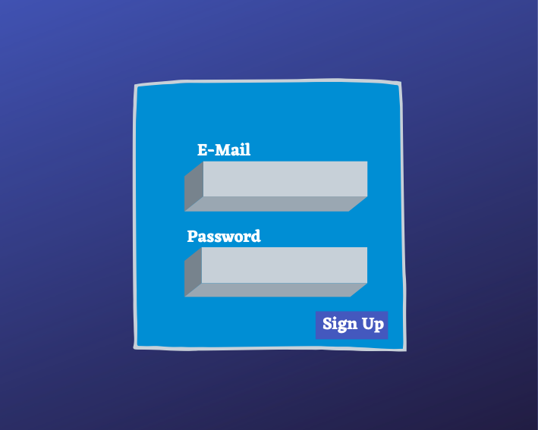or create a new survey. In this path they can enter their question into the “ENTER QUESTION” text box provided, as well as add and/or create answer choice as needed using the text box provided to supply survey takers with choices and the (+) button to create another choice if needed.



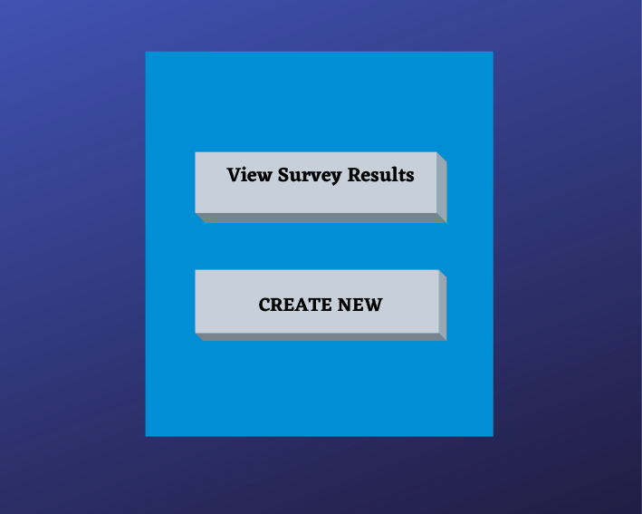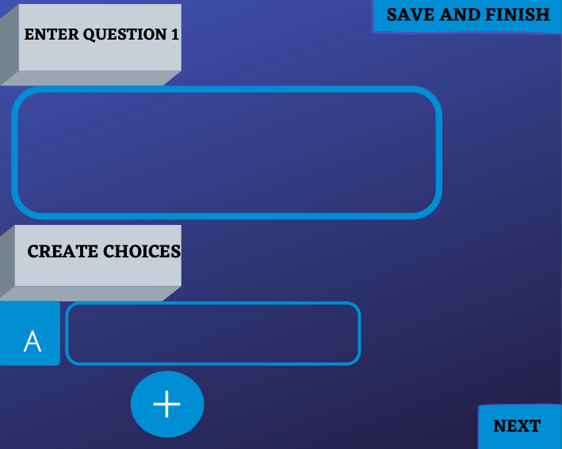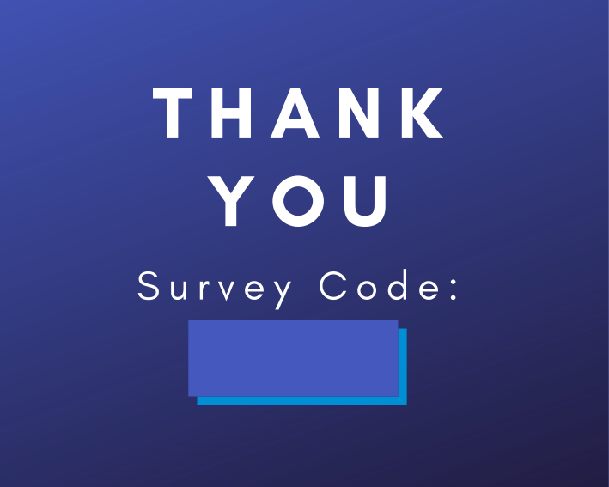

**BUSINESS/COMPANY VIEW (VIEW RESULTS)**

In this path company’s can view the result to their surveys, the format for the result would be the

question asked , answer choices to question with a graph and percentage telling them which results were the most popular … also allowing them to goto the next question or exit whenever they click either of the respective buttons.







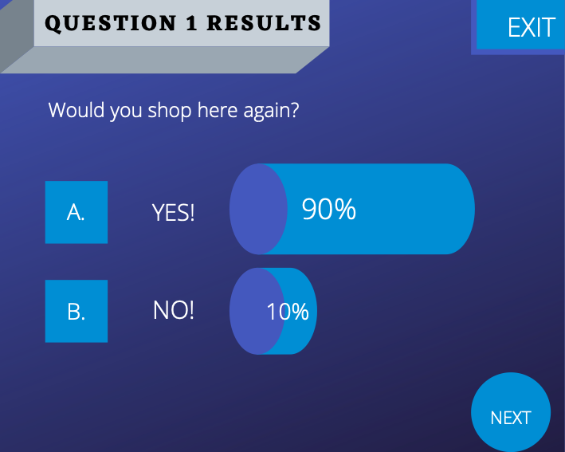

**Admin**

**Admin -**  create new users, create new survey templates, ensure permission are correct, given access to the database note admin is the only user with access to the database.

